Course: MAI511-1 - Advanced Database Technologies
LAB Exercise – V ACID Properties of Transaction
OTT Streaming Platform Management System
Name: Anugrahaa V
Roll No. 2648506

Aim
To implement and demonstrate the ACID (Atomicity, Consistency, Isolation, and Durability) properties of transactions using SQL commands in the OTT Streaming Platform Management System database. The transaction demonstrates the process of a user purchasing a subscription plan by updating the subscription details and recording the payment information while maintaining database integrity.
Scenario
A user purchases a subscription plan in the OTT Streaming Platform.
The transaction involves the following operations:
- Registering a new subscription for the user by inserting a record into the user_subscriptions table.
- Recording the payment details in the payment table.
- If both operations are completed successfully, the transaction is permanently saved using COMMIT.
- If any operation fails (such as violating a foreign key constraint), all previous operations performed within the transaction are cancelled using ROLLBACK.
- The transaction also demonstrates database consistency through constraints, isolation through concurrent transaction handling, and durability by verifying that committed changes remain stored even after restarting the database session

Initial tables (users, subscription_plans, user_subscriptions, payment)
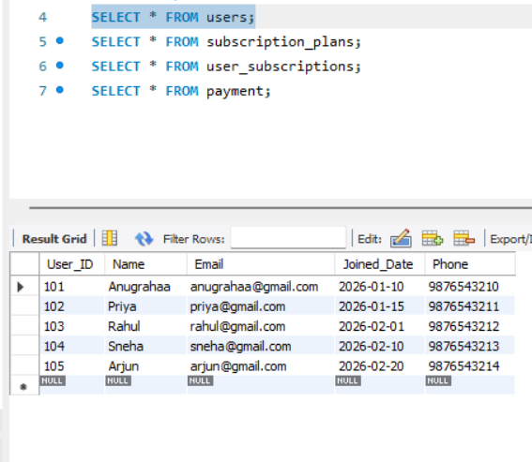
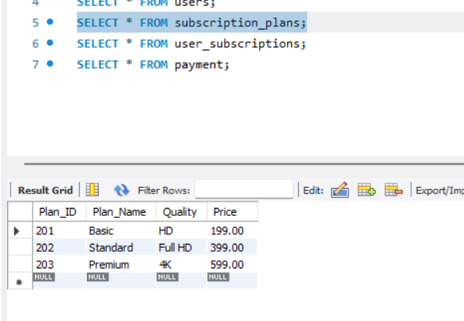
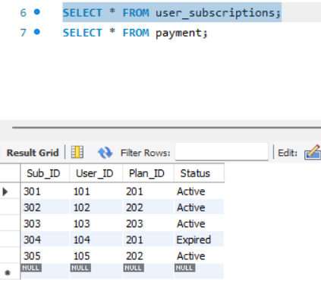
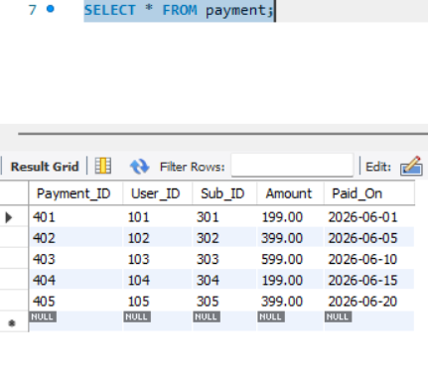

1.Atomicity
Atomicity ensures that a transaction is treated as a single unit of work. Either all the operations in the transaction are executed successfully, or none of them are executed. If any operation fails, the entire transaction is rolled back, leaving the database unchanged.
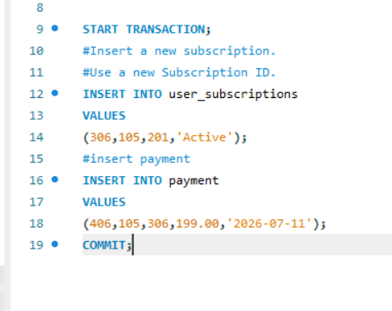
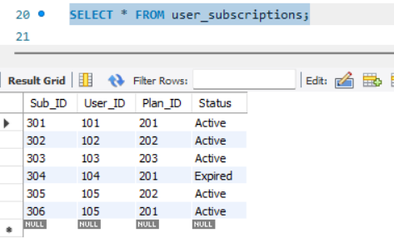
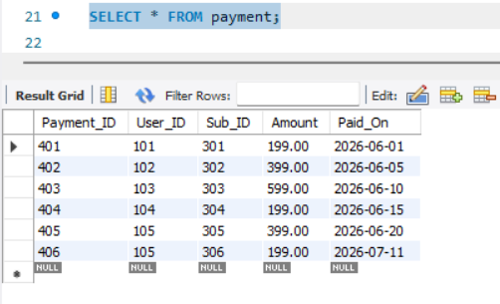
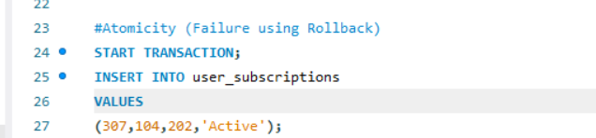

Atomicity (Failure using Rollback)
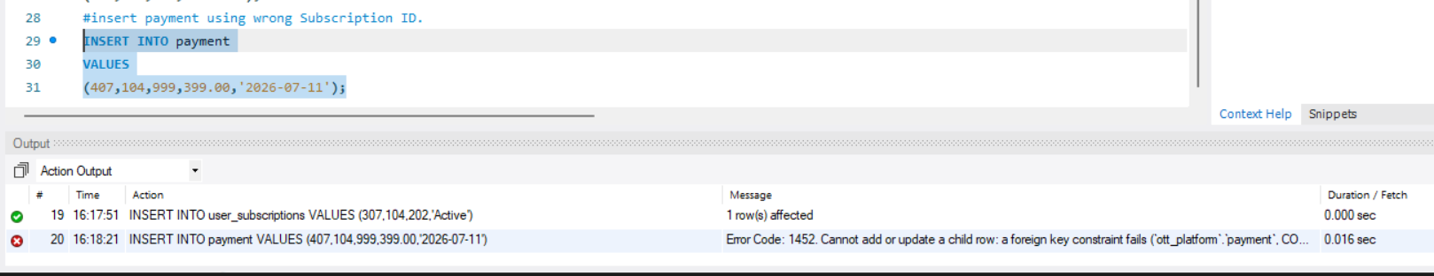
Since 999 does not exist in user_subscriptions Foreign Key Error will occur.
ROLLBACK OPERATION
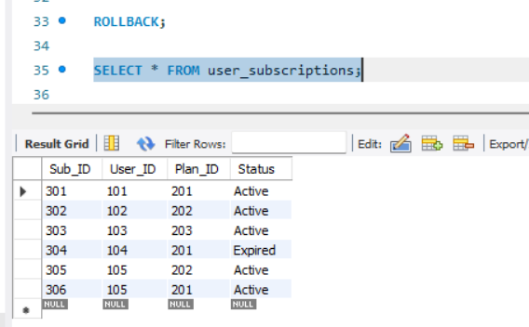
307 does NOT exist.
Rollback cancelled everything.
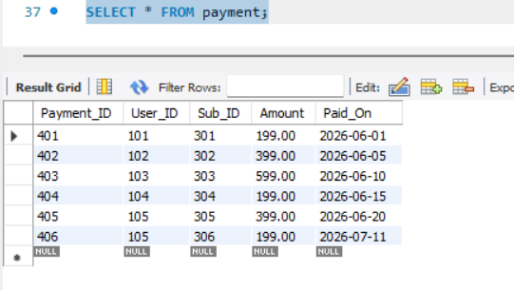
307 does NOT exist.
Rollback cancelled everything.
2. Consistency
Consistency means constraints protect the database.
Consistency ensures that a transaction takes the database from one valid state to another valid state by enforcing all integrity constraints such as Primary Key, Foreign Key, UNIQUE, NOT NULL, and CHECK constraints.

valid insert.
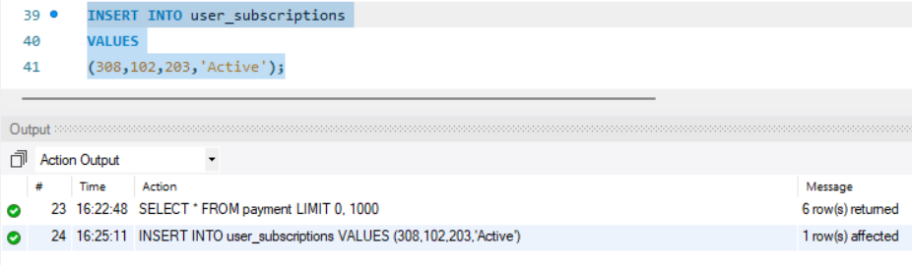
Invalid Insert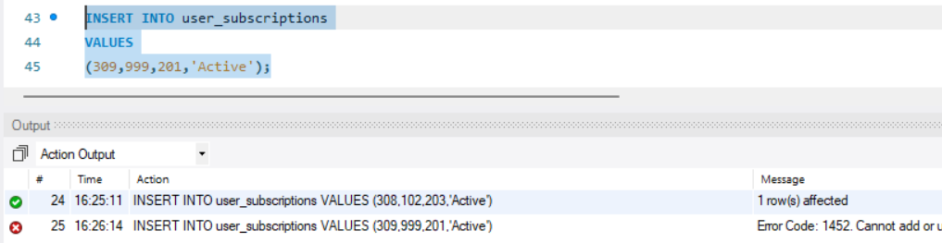
User 999 doesn't exist.
Foreign Key Error.
Database remains consistent.
3. Isolation
If one transaction is updating the subscription plan price, another transaction cannot access the uncommitted updated value until the first transaction is committed.
Window 1 Before Commit
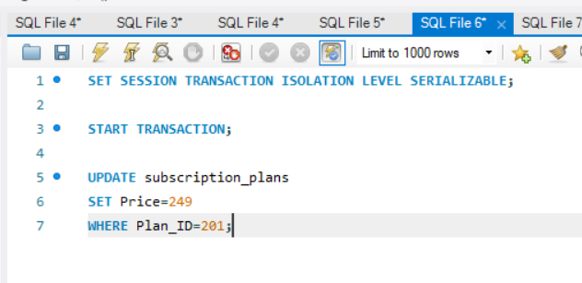

Window 2

You will still see 199 because Transaction 1 hasn't committed.
Window 1 After Commit
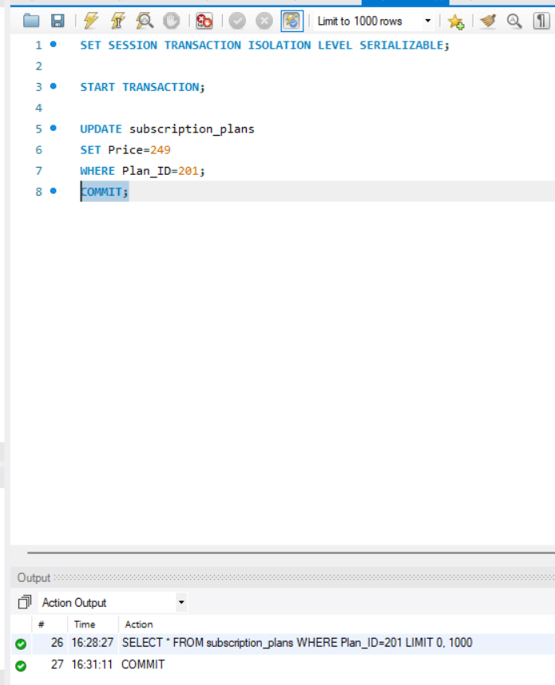
Window 2
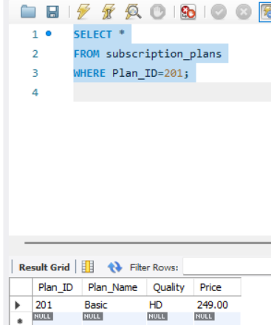
Now 249 appears.
4. Durability
Durability ensures that once a transaction is committed, its changes are permanently stored in the database. The committed data remains available even if the database session is closed or the system is restarted.
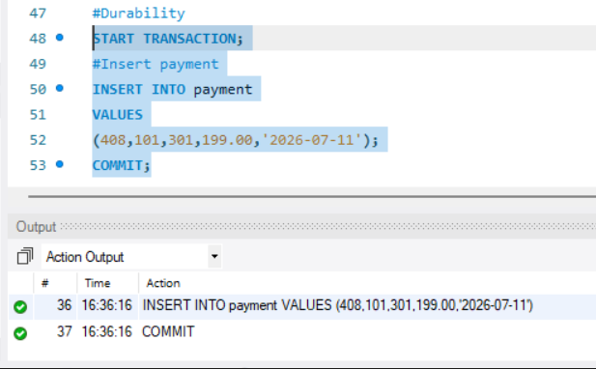
Disconnected MySQL.
Then Reconnect.
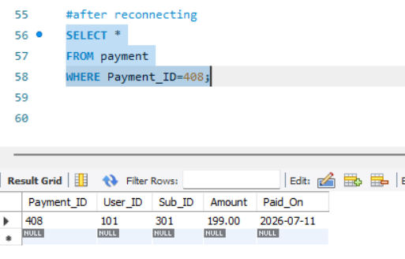
Record still exists.
This proves durability.

Result
The ACID properties of transactions were successfully implemented and demonstrated using the OTT Streaming Platform Management System database. Atomicity was verified using COMMIT and ROLLBACK, Consistency was maintained through primary key and foreign key constraints, Isolation was demonstrated using transaction isolation levels during concurrent transactions, and Durability was verified by confirming that committed data remained permanently stored even after reconnecting to the database.
This confirms that the database transactions are executed reliably while preserving data accuracy, integrity, and persistence.

